**Mendocino College**

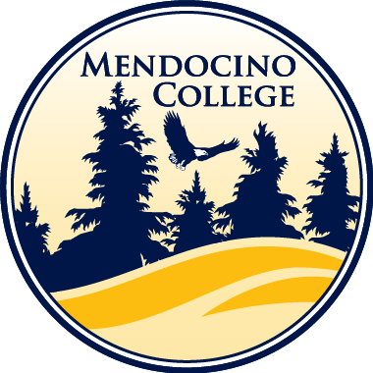**DAM 110 –** Image Manipulation with Photoshop

**Course Schedule –** Spring 2023

**Weekly Topics**

1) Introduction to Adobe Photoshop

* Adobe Photoshop
* Adobe Bridge
* Screenshots
* Effective File Management

2) Layers / Transparency / File Formats / Transform, Zoom, & Move Tools.

3) Text Tool / Layer Styles / Fill & Adjustment Layers

4) Filters / Blending Modes / Importing Images / Crop, Frame, & Slice Tools / Contact Sheets

5) Lasso, Selection, Marquee, Brush, & Eraser Tools.

6) Shapes / Pen Tool / Resolution.

7) Masks / Gradient & Paint Bucket Tool.

8) Portfolio Site / Watermarks

9) Visual Design / Colour Theory / Gamuts / Composition

10) Colour Correction / Replacing Colours / Black & White

11) Photo Corrections / Retouching / Restoration

12) History / Stamp and Brush Tools

13) Liquefy / Importing Video / Camera Raw / Lightroom

14) Careers & Professions / Resume & Cover Letter

15) Thanksgiving Holiday / Holiday Card

16) How Digital Cameras work

17) Final Examinations and Project Presentations